# **ASSIGNMENT-4**

## **DISTANCE DETECTION USING ULTRASONIC SENSOR**

|  |  |
| --- | --- |
| Date | 22 October 2022 |
| Team ID | PNT2022TMID19593 |
| Name | Raghul A |
| Student Roll Number | 722819106073 |
| Maximum Marks | 2 Marks |

***QUESTION:***

Write code and connections in wokwi for ultrasonic sensor. Whenever distance is less than 100 cms send "alert" to ibm cloud and display in device recent events.

***WOKWI LINK:***

https://wokwi.com/projects/305566932847821378

***CODE:***

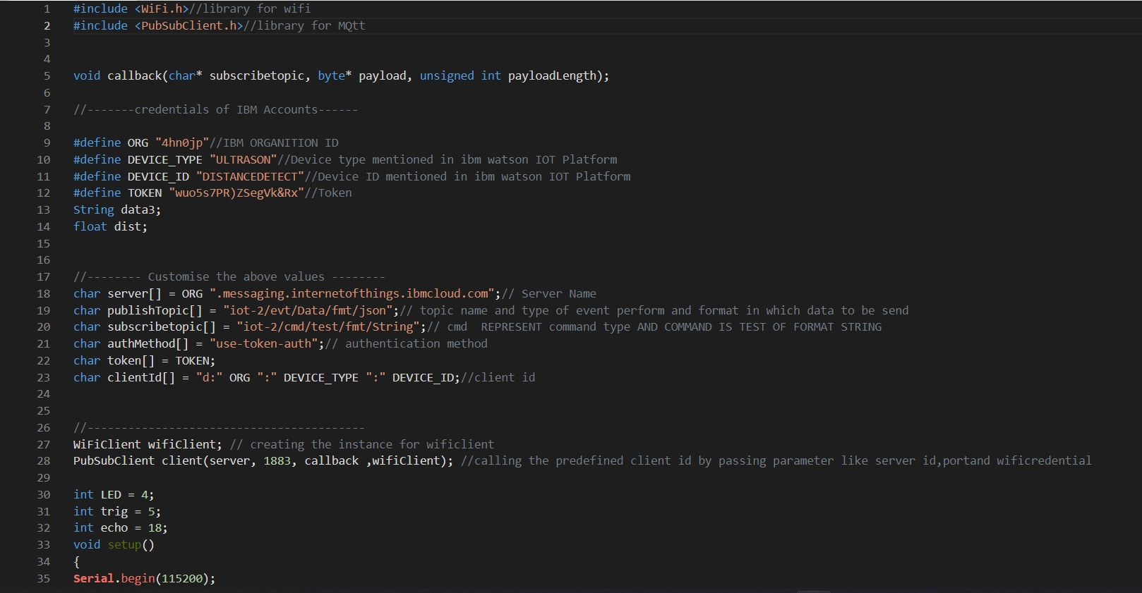

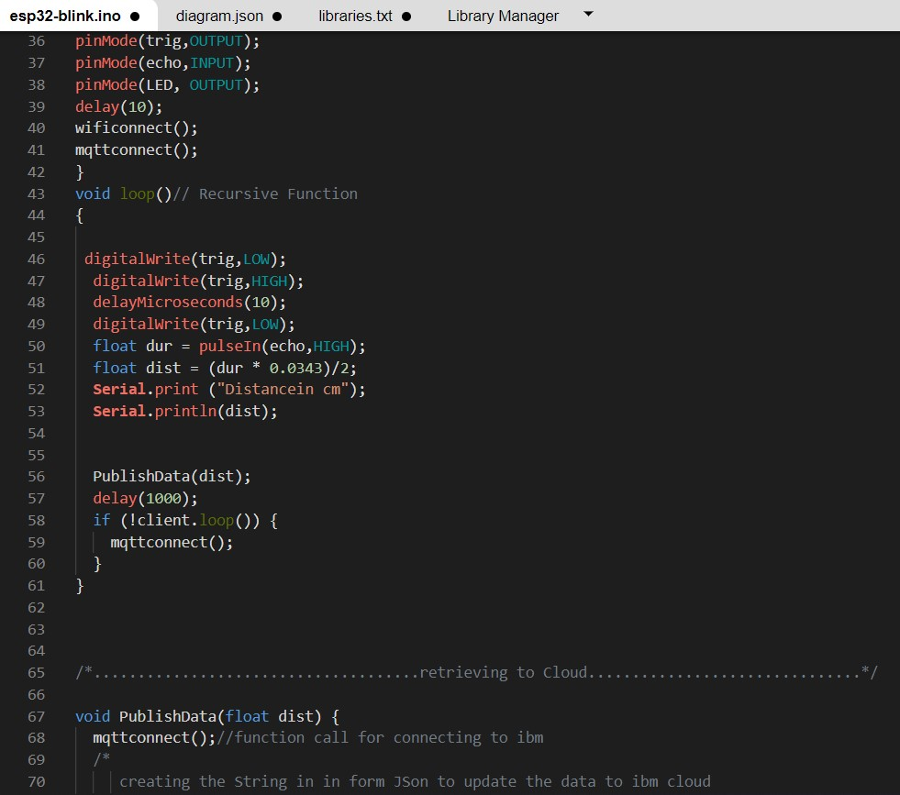

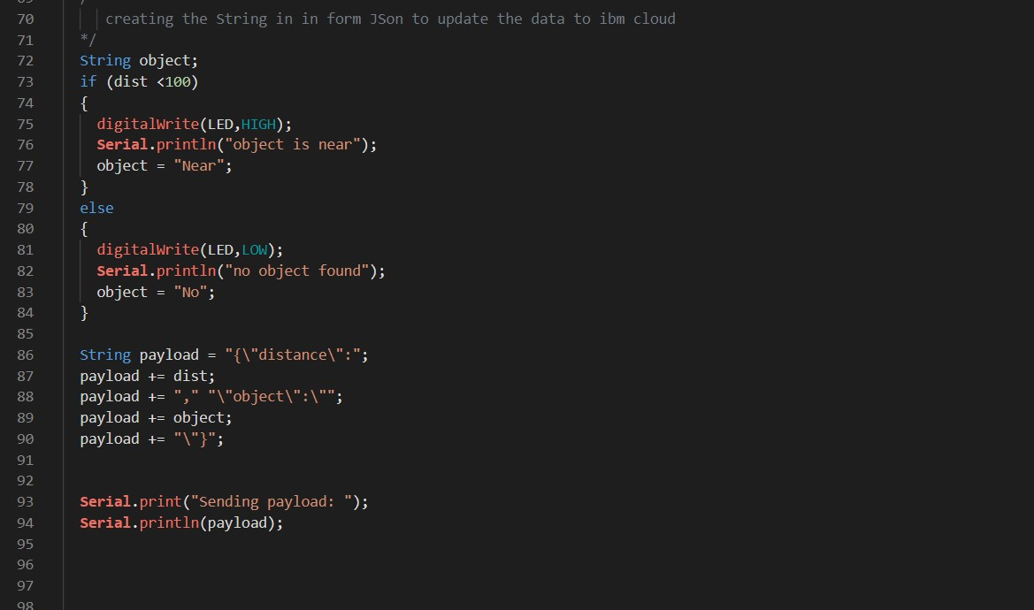

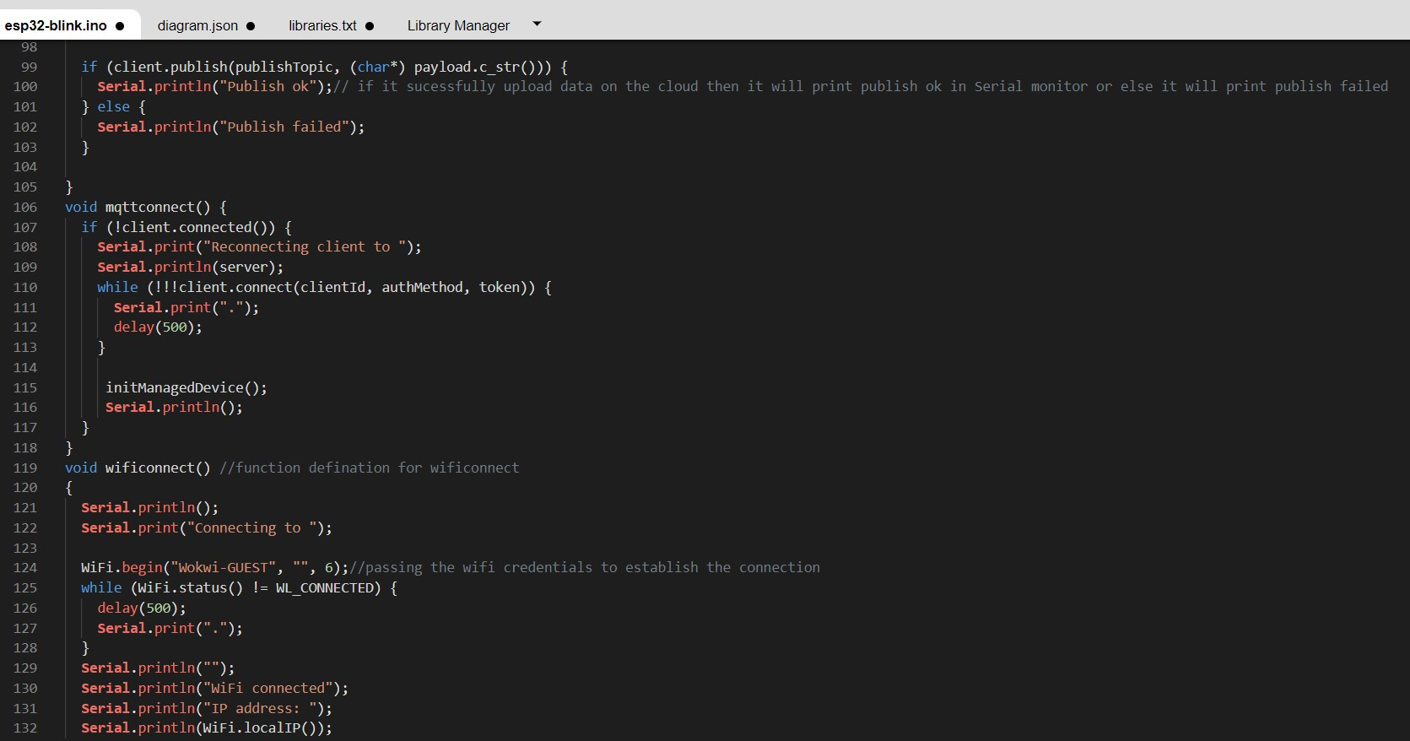

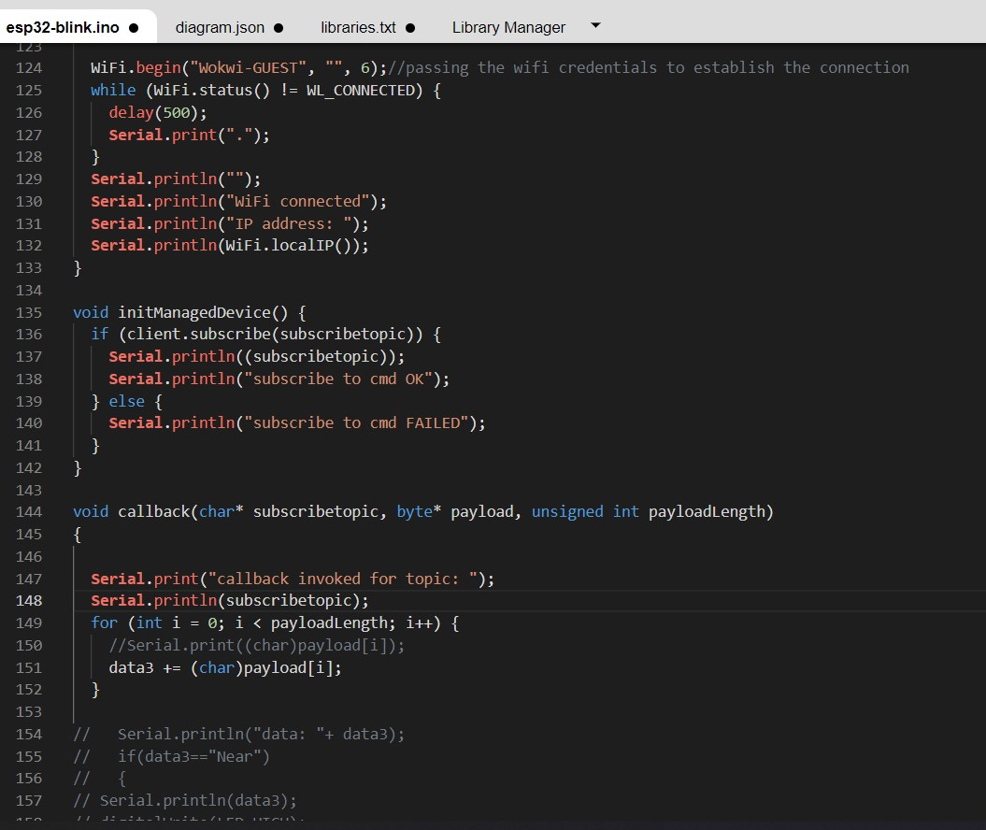

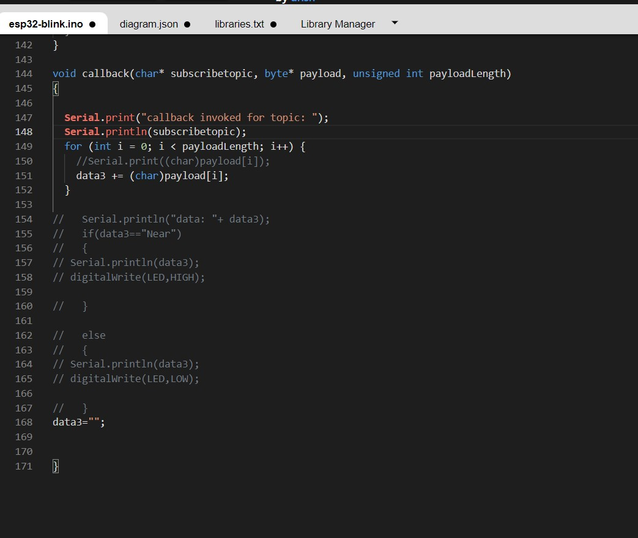

OUTPUT:

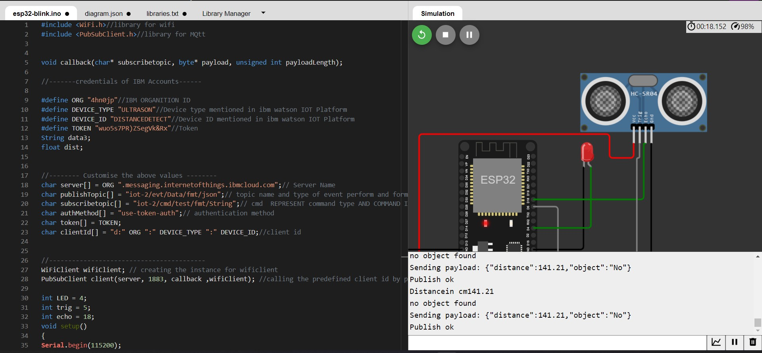

# Data send to the IBM cloud device when the object is far

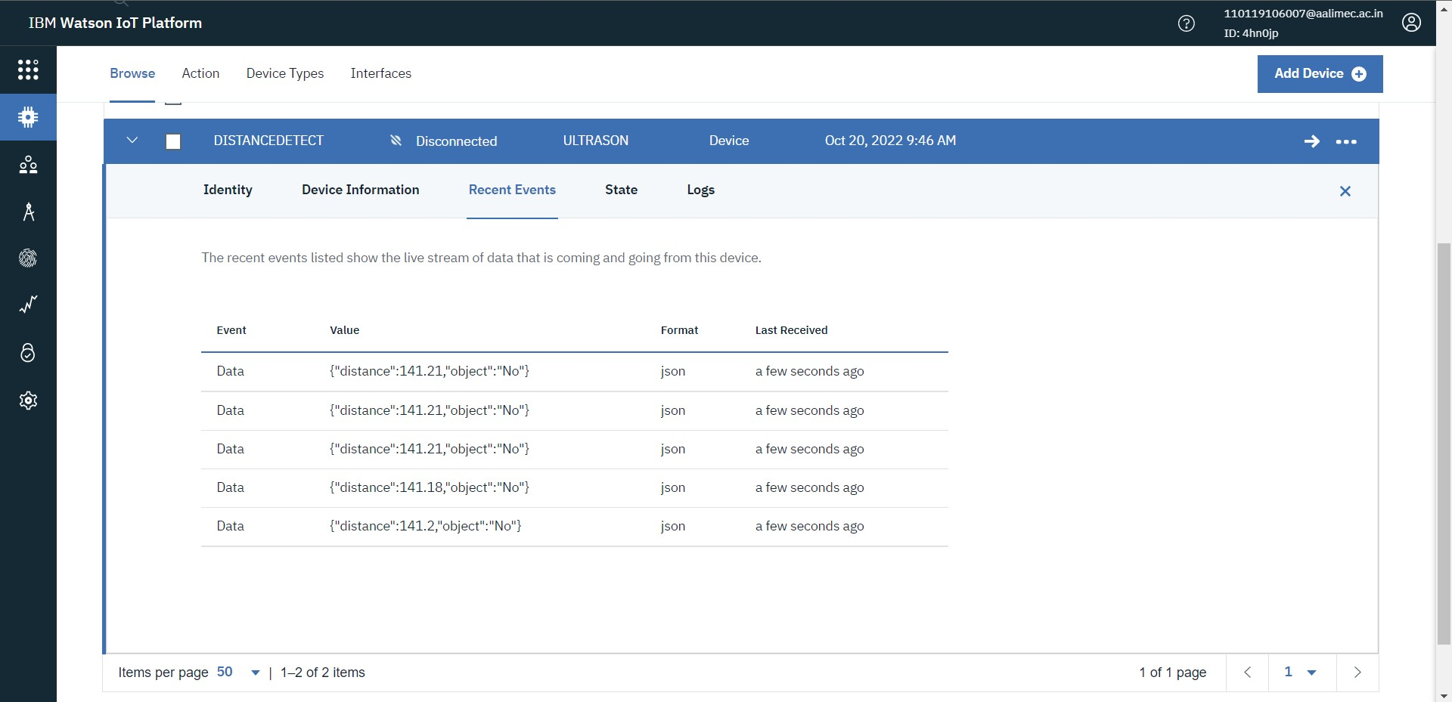

# **when object is near to the ultrasonic** **sensor**

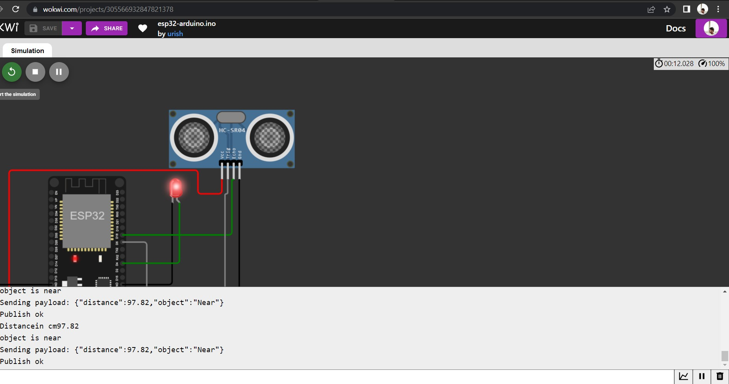

# **Data sent to the IBM Cloud Device when the object is near**

